Project Title :
Digital voting system
SUBMITTED BY:
- Shaharyar Faisal (70153126)
- Saqib Amjad (70153179)
- Qamar Rasool (70152436)

Git Hub profiles :
https://github.com/70152436-netizen/Digital-voting-system-
https://github.com/sherry589/Digital-Voting-System
https://github.com/saqibamjad7

1. Project Scenario
The Digital Voting System is a secure, lightweight, and decentralized relational database application designed to manage and streamline democratic voting processes. The scenario simulates a local or national election context featuring three primary political leaders/parties and an initial electorate base of thirty citizens.
The application governs user registration, age eligibility filtering, strict single-credential citizen authentication, vote logging, and immediate programmatic calculation of election results. The primary design objective is ensuring absolute systemic integrity—preventing non-registered entities from participating and programmatically eliminating double-voting.
2. Core Entities
The architecture isolates data management into three distinct, specialized real-world objects:
Voters: Represents individual citizens eligible to cast a ballot. It holds critical profile details, authentication secrets, and current clearance state.
Candidates: Represents political contestants running for public office. It maintains identity, faction mapping, and their dynamic real-time performance tallies.
Votes: Represents the secure transaction log ledger. It archives which voter successfully completed a transaction and where that transaction's weight was directed.
3. Design Principles Applied
To make this project highly robust yet accessible to a beginner developer executing code within standard sandboxes like OneCompiler, specific database practices were prioritized.

Explicit State Locking:
Instead of reading complex multi-table histories dynamically to determine if a user can access the system, the has_voted flag instantly exposes eligibility, drastically dropping compute costs for authentication.
Encapsulated Transactions:
The process of casting a ballot requires atomic synchronization—creating a record, bumping the running total, and locking the user must happen concurrently to ensure consistency.
De-normalization for Performance (No Triggers/Joins):
While advanced schemas compute vote tallies dynamically using standard aggregating functions on the historical ledger, this design maintains a persistent, static vote_count property inside the Candidates model for fast, look-up query extraction.

Relationship Summary & Structural MappingRelationship:
ExplanationsVoters to Votes (1 -> 0..1): A strict single-participation relationship. A registered citizen listed in the system can either have zero recorded voting transactions (yet to vote) or exactly one recorded voting transaction. They are structurally forbidden from appearing multiple times in the ledger.
Candidates to Votes (1 ->Many):
A traditional gathering relationship. A single political candidate can be chosen by multiple distinct voters, meaning their unique identifier can appear many times across separate rows in the transactional ledger.

Feature 1: Register a New Voter
Adds a 31st voter to the system with a unique Pakistani name.
INSERT INTO Voters (voter_id, voter_name, email, age, password)
VALUES (31, 'Fawad', 'fawad@email.com', 26, 'fawadPass31');
-- View the voters table to confirm he was added
SELECT * FROM Voters;
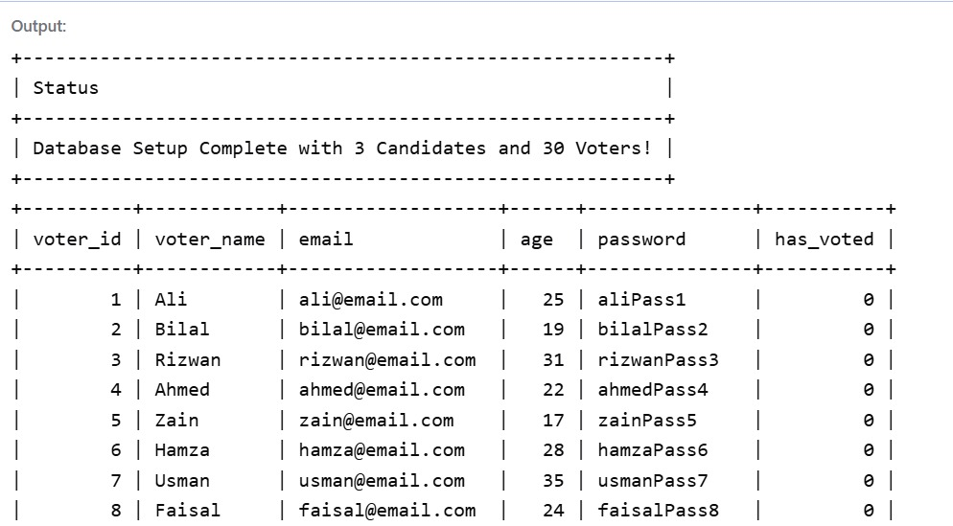

Feature 2: View All Registered Candidates
Shows the 3 political candidates running in the election.

SELECT candidate_id, candidate_name, party_name
FROM Candidates;

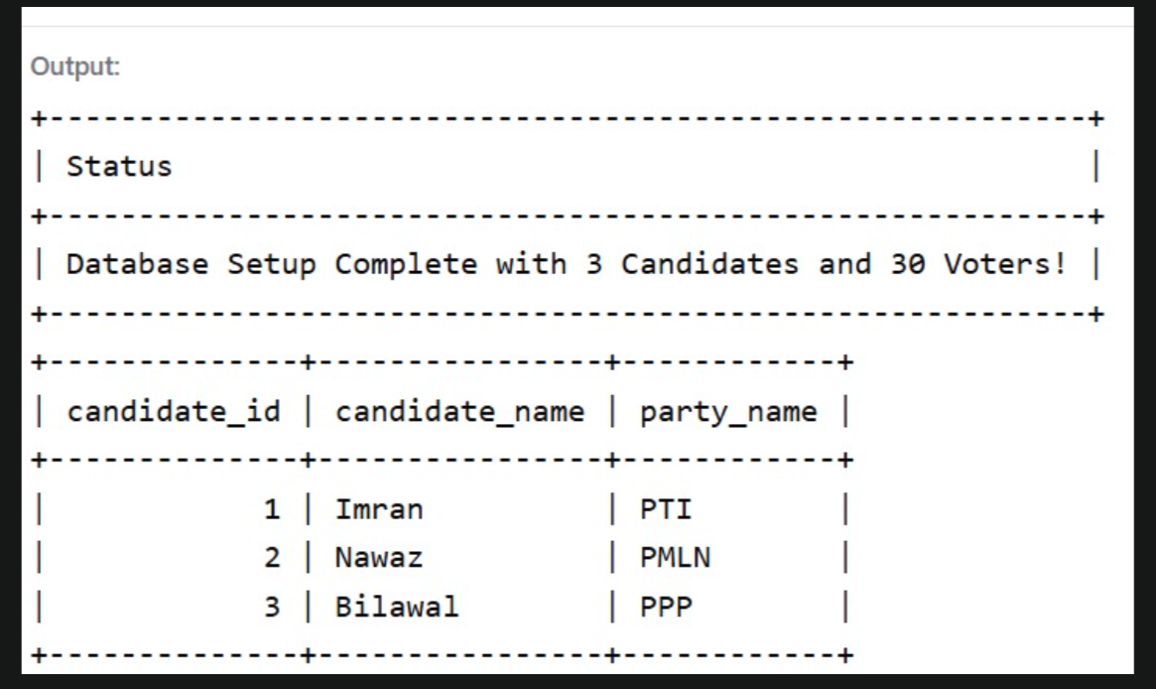
Feature 3: Check Voter Eligibility (Age Verification)
Filters the 30+ voters to show only those who are 18 or older (underage voters like Zain will hide).

SELECT voter_id, voter_name, age
FROM Voters
WHERE age >= 18;

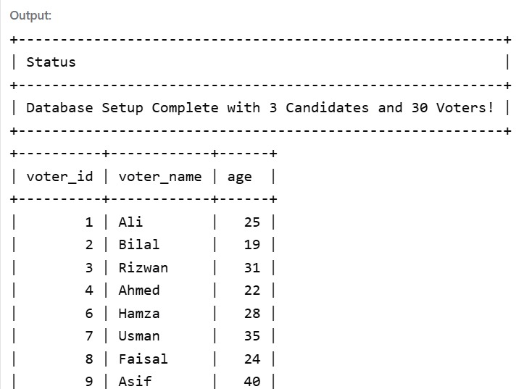

Feature 4: Secure Voter Login & Check Double-Voting
Verifies Rizwan's credentials. If has_voted = 0, it returns his info, meaning he is clear to vote.

SELECT voter_id, voter_name
FROM Voters
WHERE email = 'rizwan@email.com'
AND password = 'rizwanPass3'
AND has_voted = 0;
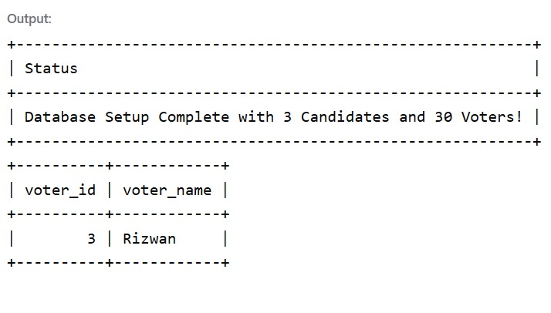

Feature 5: Cast a Vote
Logs a vote into the system. Here, Voter ID 3 (Rizwan) casts a vote for Candidate ID 1 (Imran).

INSERT INTO Votes (vote_id, voter_id, candidate_id)
VALUES (101, 3, 1);

-- View the votes table to confirm the vote was recorded
SELECT * FROM Votes;
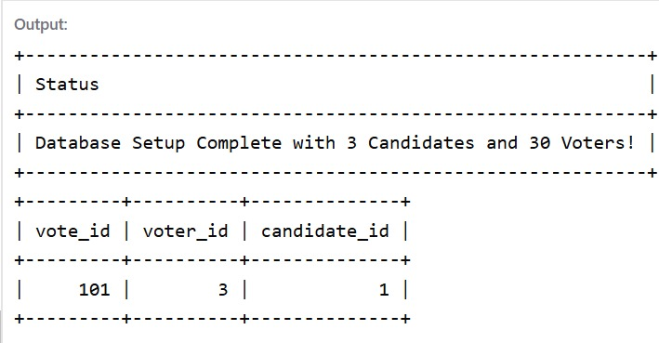

Feature 6: Update Candidate's Vote Count
Increments Candidate 1's (Imran's) total score by 1 because of Rizwan's vote.

UPDATE Candidates
SET vote_count = vote_count + 1
WHERE candidate_id = 1;

-- Check the candidate table to see the updated tally
SELECT * FROM Candidates;

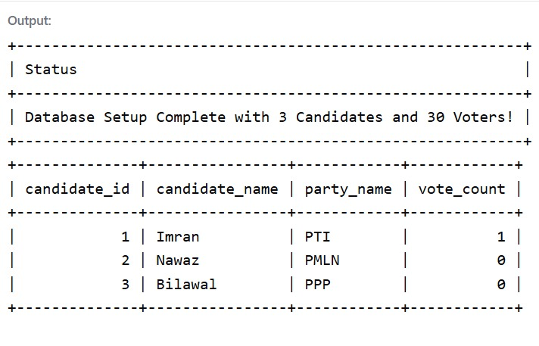

Feature 7: Lock Voter Status (Prevent Double-Voting)
Changes Rizwan's (voter_id = 3) status to 1. He will now fail Feature 4 if he tries to log in again.

UPDATE Voters
SET has_voted = 1
WHERE voter_id = 3;

-- Verify that his status is now 1
SELECT voter_name, has_voted FROM Voters WHERE voter_id = 3;
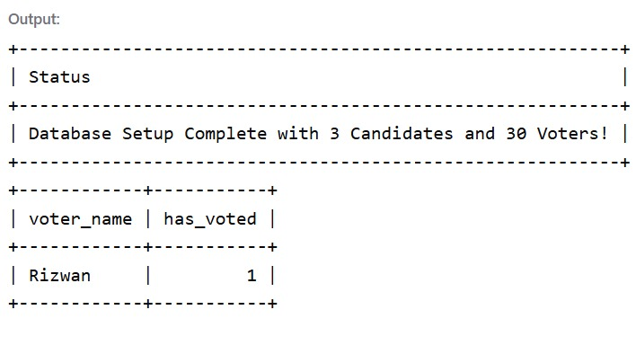

Feature 8: Display Live Election Results
Displays all candidates sorted by who has the most votes at the moment.

SELECT candidate_name, party_name, vote_count
FROM Candidates
ORDER BY vote_count DESC;

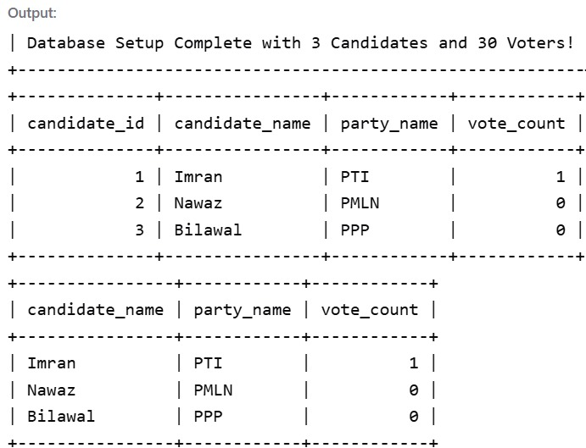

Feature 9: Count Total Turnout
Counts how many rows are in the Votes table to see how many total citizens have participated.

SELECT COUNT(vote_id) AS total_votes_cast
FROM Votes;

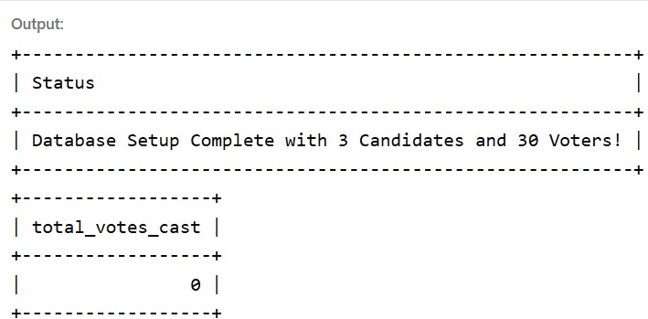

Feature 10: Find the Winner
Instantly returns only the single candidate who is currently leading the race.

SELECT candidate_name, party_name, vote_count
FROM Candidates
ORDER BY vote_count DESC
LIMIT 1;

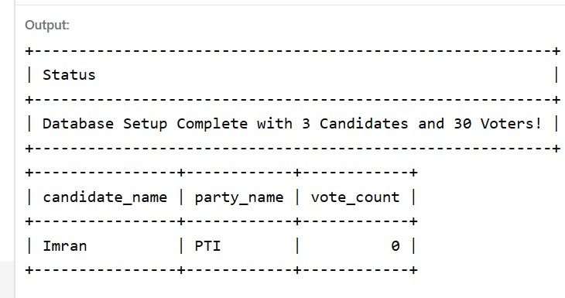

Feature 11: Full Turnout Simulation & Final Election Result

-- ========================================================
-- 1. CAST VOTES FOR ALL 30 VOTERS
-- (Simulating who each person voted for)
-- ========================================================
INSERT INTO Votes (vote_id, voter_id, candidate_id) VALUES
(101, 1, 1), (102, 2, 1), (103, 3, 2), (104, 4, 1), (105, 5, 3),
(106, 6, 1), (107, 7, 2), (108, 8, 1), (109, 9, 2), (110, 10, 3),
(111, 11, 1), (112, 12, 1), (113, 13, 2), (114, 14, 1), (115, 15, 3),
(116, 16, 1), (117, 17, 2), (118, 18, 1), (119, 19, 2), (120, 20, 3),
(121, 21, 1), (122, 22, 1), (123, 23, 2), (124, 24, 1), (125, 25, 3),
(126, 26, 1), (127, 27, 2), (128, 28, 1), (129, 29, 2), (130, 30, 1);

-- ========================================================
-- 2. TALLY AND UPDATE THE CANDIDATES' VOTE COUNTS
-- (Based on the simulated votes above)
-- ========================================================

-- Imran (Candidate 1) received 16 votes
UPDATE Candidates SET vote_count = 16 WHERE candidate_id = 1;

-- Nawaz (Candidate 2) received 9 votes
UPDATE Candidates SET vote_count = 9 WHERE candidate_id = 2;

-- Bilawal (Candidate 3) received 5 votes
UPDATE Candidates SET vote_count = 5 WHERE candidate_id = 3;

-- ========================================================
-- 3. MARK ALL 30 VOTERS AS "HAS VOTED" (100% Turnout)
-- ========================================================
UPDATE Voters SET has_voted = 1;

-- ========================================================
-- 4. DISPLAY THE FINAL RESULTS & WINNER
-- ========================================================

-- Show the complete scoreboard
SELECT 'FINAL SCOREBOARD' AS 'Election Phase';

SELECT candidate_name, party_name, vote_count
FROM Candidates
ORDER BY vote_count DESC;

-- Show the total voter turnout count (Should be 30)
SELECT COUNT(vote_id) AS total_final_votes
FROM Votes;

-- Declare the official winner of the election
SELECT 'OFFICIAL WINNER DECLARATION' AS 'Result';

SELECT candidate_name AS winner_name, party_name AS winning_party, vote_count AS total_winning_votes
FROM Candidates
ORDER BY vote_count DESC
LIMIT 1;
